Dear Reality updates spatializer and virtual monitoring plugins
Introducing patented Clarity algorithm, Apple Logic Pro and Apple M1 support

Düsseldorf, June 2022 – Immersive audio specialist Dear Reality has announced a series of exciting updates to its spatializer, monitoring and mixing plug-ins. The dearVR PRO and dearVR MUSIC spatializer plugins now include the patented Sennheiser AMBEO Clarity algorithm for next-level binaural productions with less audible frequency coloration. Also, dearVR PRO and dearVR MONITOR now fully support Apple Logic Pro’s multi-channel formats and Dolby Atmos workflows, enabling the user to monitor and create multi-channel mixes and Atmos productions. The company’s Spatial Headphone Compensation (as used in dearVR MIX and dearVR MONITOR) additionally features Sennheiser’s top-of-the-range closed-back model, the HD 300 PRO, while native Apple Silicon M1 compatibility makes all Dear Reality plugins the perfect solution for immersive desktop or remote productions.

New Clarity Feature – enhanced possibilities for professional binaural audio productions
Binaural audio processing is a great way to add a new sound dimension to audio productions. By adding the Sennheiser AMBEO Clarity algorithm, Dear Reality enables users to reduce unwanted signal alterations resulting from head-related transfer functions (HRTF), thus taking the binaural processing to the next level. “A human voice, for example, is so familiar to us that even slight changes already have a huge impact, while synthesized sounds need stronger binaural filtering to be perceived as coming from the correct direction,” explains Christian Sander, co-CEO of Dear Reality.

The new Clarity feature in dearVR PRO and dearVR MUSIC lets users define the perfect balance between externalization and colorization, depending on the direction and source material. This also facilitates the smooth transfer to regular stereo loudspeaker playback devices.

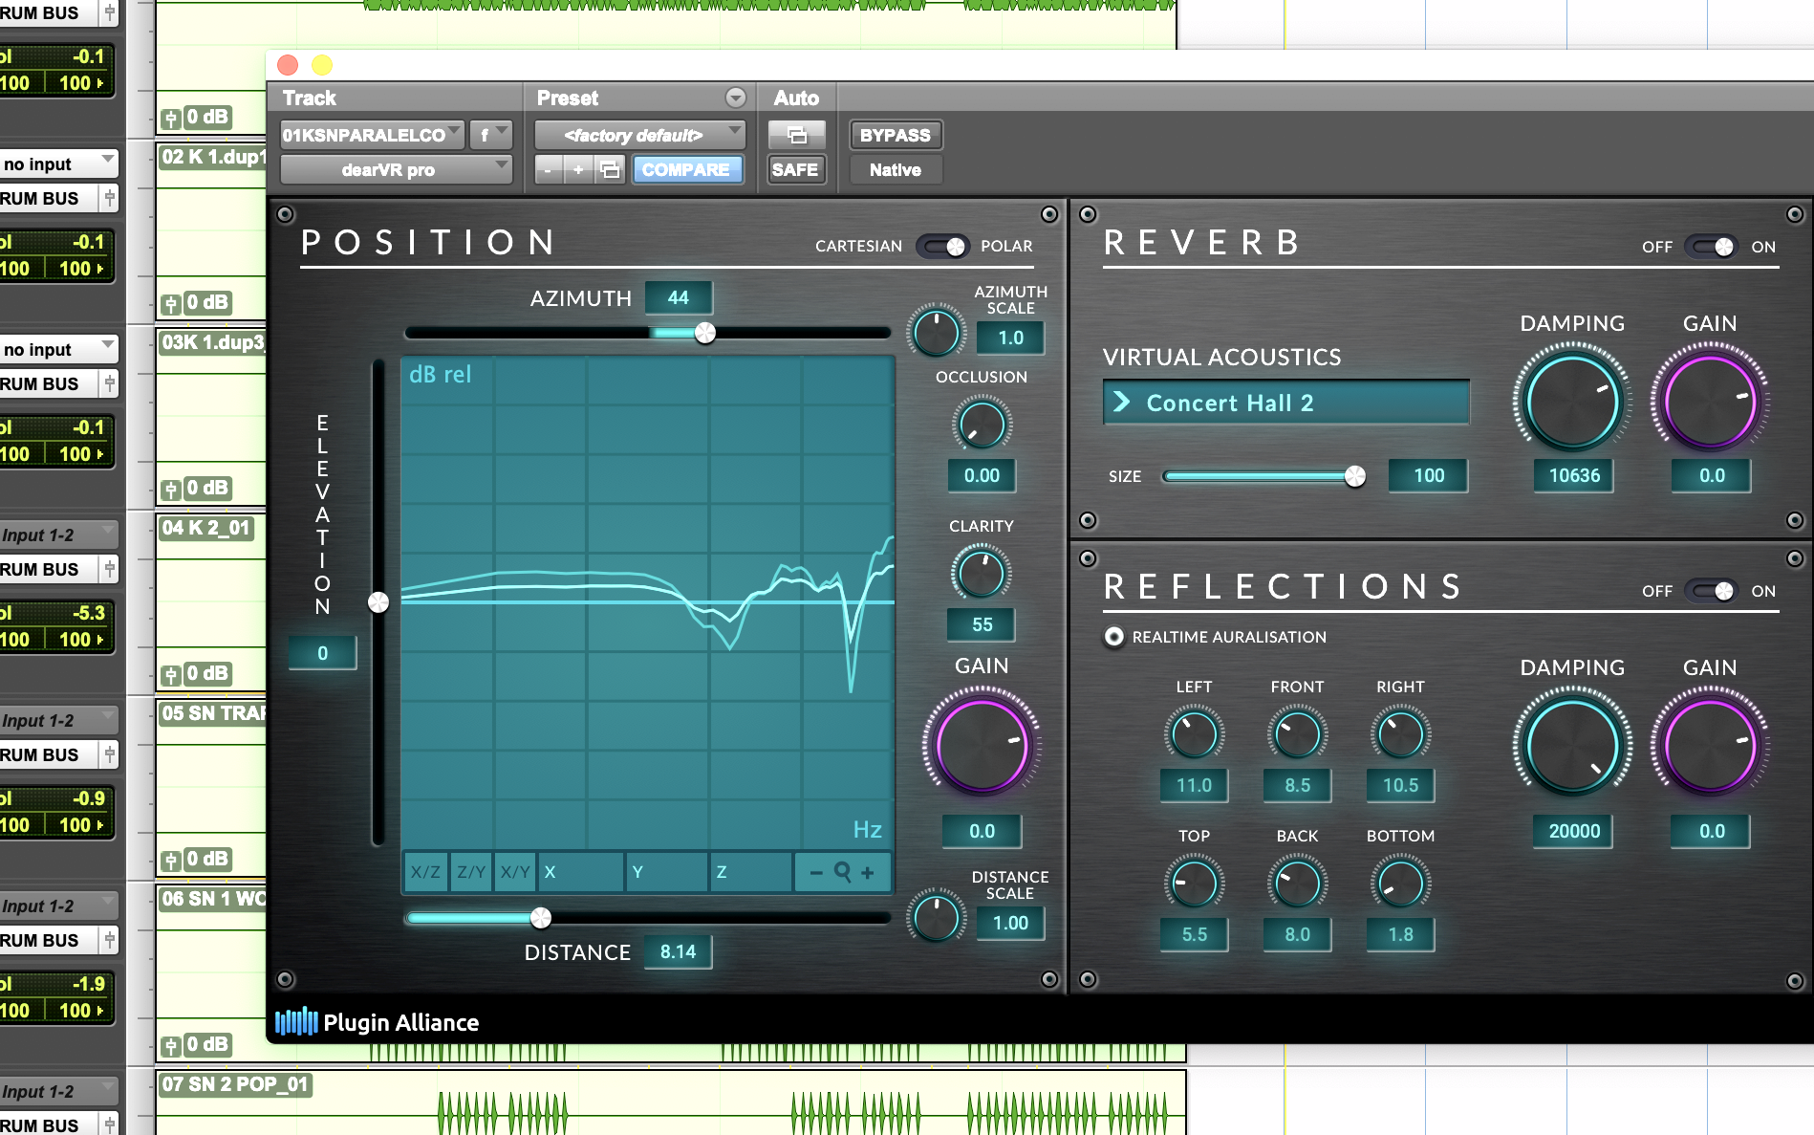 | The new Clarity feature lets users set the perfect balance between externalization and colorization

dearVR PRO and dearVR MONITOR – added multi-channel compatibility for Apple Logic Pro v.10.7
dearVR PRO and dearVR MONITOR now fully support Apple Logic Pro’s integrated Dolby Atmos workflow, enabling users to enhance immersive sessions up to 7.1.4.

With dearVR PRO, the state-of-the-art binaural, Ambisonics, and multi-channel spatializer, Logic users have a full 360° immersive panner at their fingertips, placing the listener at the center of sound in 46 vivid virtual acoustic environments for modern professional music production and post production.

dearVR MONITOR, on the other hand, enables them to monitor all common speaker setups simply via headphones – anytime and anywhere, without the limitations imposed by unreliable room acoustics or missing multi-channel speaker setups. dearVR MONITOR offers a perfect virtual mix room to reliably produce in 26 multi-channel loudspeaker formats.

Spatial Headphone Compensation
Dear Reality has also expanded the Spatial Headphone Compensation in dearVR MONITOR and dearVR MIX with additional headphone models, including the Sennheiser HD 300 PRO. These two plugins now support Sennheiser’s entire professional studio headphone range from the legendary HD 25 to the open-back HD 400 PRO.

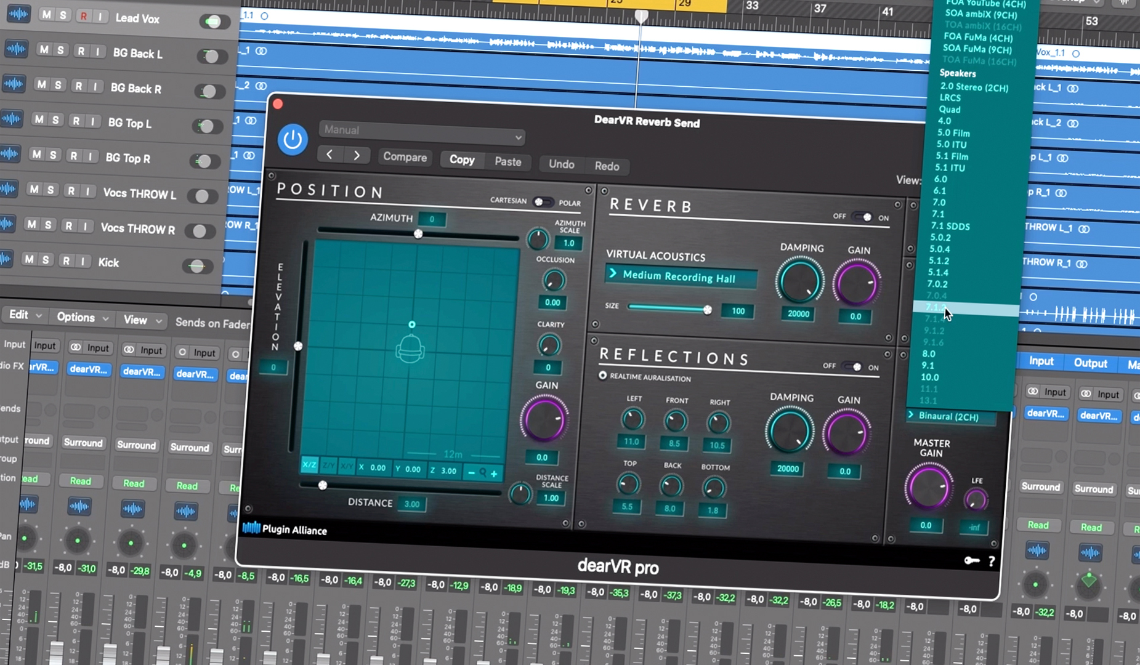 | Dive into immersive productions with dearVR PRO, dearVR MONITOR and Apple Logic Pro

Apple Silicon M1 compatibility
The latest versions of Dear Reality’s dearVR PRO and dearVR MUSIC spatializers as well as dearVR MONITOR and dearVR MIX monitoring solutions provide fully native Apple Silicon support. This makes these plugins the perfect tools for immersive desktop or remote productions, leveraging the full performance of Apple M1 devices.

More information
For more information, please also visit the Dear Reality blog https://blog.dear-reality.com/overview/introducing-clarity and watch the Clarity walkthrough video at https://youtu.be/LG2zca7iC1U.

(Ends)

Apple and Logic Pro are trademarks of Apple Inc., registered in the U.S. and other countries and regions.
Dolby and Dolby Atmos are trademarks of Dolby Laboratories, registered in the U.S. and other countries and regions.

The images accompanying this media release can be downloaded here.

About Dear Reality
Dear Reality is a leading company in the field of immersive audio controllers, best known for its binaural, Ambisonics, and multichannel encoders with totally realistic room virtualization. The company’s products are used worldwide by sound engineers, sound designers, broadcasters, and musicians. Founded in 2014 by Achim Fell and Christian Sander, Dear Reality strives to deliver high-quality, cutting-edge 3D audio software for interactive and linear audio production. Since 2019, Dear Reality has been proud to be a part of the Sennheiser Group.

Local Press Contact Global Press Contact

Kai Detlefsen
press@dear-reality.com

